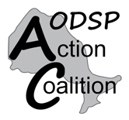
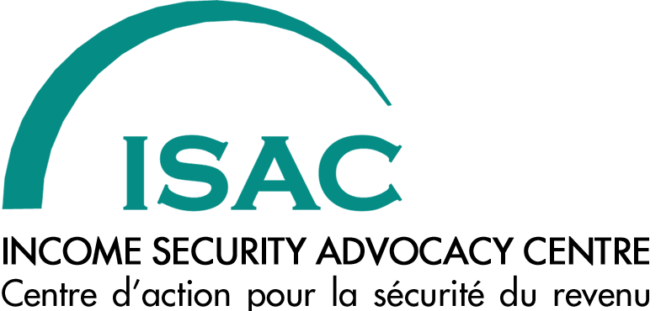

Ontario Election 2014

Questions for Local Candidates
on the Ontario Disability Support Program (ODSP)

The ODSP Action Coalition is a network of people who receive ODSP, disability organizations, community legal clinics and other social agencies who work with people with disabilities. The Coalition pushes for improvements to ODSP law and policies by writing letters or meeting with politicians and government officials, educating members and the public about ODSP issues, helping ODSP recipients develop skills to advocate for themselves, and writing submissions and making presentations to provincial commissions and committees. The Coalition has organized advocacy workshops and conferences and members have participated in rallies and demonstrations.

The Income Security Advocacy Centre (ISAC) is a specialty legal clinic funded by Legal Aid Ontario with a provincial mandate to improve the income security of people living in Ontario through test case litigation, policy advocacy and community organizing. ISAC works closely with sixty community legal clinics who work every day with the challenges faced by low-income people relying on Ontario’s income security programs, Ontario Works (OW) and ODSP. ISAC also works with advocacy groups and organizations like the ODSP Action Coalition.
As part of the work we are doing together on the 2014 provincial election, we have created three key questions on ODSP-related issues that people can ask of candidates from all political parties who are running for election in ridings across the province. Election Day is June 12.
The questions are on page two. After that are two pages of background information that might be helpful when you are talking with the candidates about these issues.
Use the questions when candidates come to your door asking for your support or at All Candidates’ Meetings that may be held in your community. You can also use them as the basis for doing media outreach or community development with people on ODSP during the election campaign.
More information about doing election-related work is in ISAC’s Ontario Election 2014 Kit on the ISAC election webpage at http://www.incomesecurity.org/OntarioElection2014.htm.
We are also sending ODSP-related questions to each of the political parties and will be making the answers that we receive public in advance of Election Day. This will give people across the province information about where each of the parties stands on important issues for people who rely on ODSP. We hope this will help people decide which party they want to support.

Check the ISAC election webpage closer to June 12 to see where the parties stand.

Questions for Local Candidates
about the Ontario Disability Support Program
Ontario Election 2014

1. Income Adequacy

People relying on ODSP benefits struggle to make ends meet. A single person on ODSP gets a total income of only $13,990 per year, including all tax credits. That’s nearly $7,000 below Ontario’s recognized poverty line. But people with disabilities not only have regular costs like food and rent, they also have longer-term costs, like furniture and other items, and costs that arise from their disability.

Will your party commit to making sure that the incomes people get when they’re on ODSP are enough to afford all the regular costs of living, in addition to long-term needs and the costs of having a disability? What specific steps will you take to make ODSP incomes adequate?

2. A Dedicated Program for People with Disabilities

People with disabilities have unique needs and many need long-term support. The Ontario Disability Support Program recognizes that people with disabilities may need assistance for longer periods of time, unlike Ontario Works which is supposed to give short-term help. Recently, recommendations were made to merge ODSP with OW to make one integrated program. But there is strong public concern about this idea, which seems to be directed only at saving money and not at ensuring good services for people with disabilities.

Will your party commit to maintaining a separate income support program designed to meet the needs of people with disabilities?

3. Supports for Employment

People with disabilities on ODSP want opportunities to work and to receive training or education. They have different levels of ability to work and some are able to work sometimes and not at other times. But the employment supports and training opportunities available through ODSP are ineffective and have frustrated peoples’ efforts to gain education or employment.

What will your party do to support the employment goals of people with disabilities, recognizing that people have different levels of ability to work?

Background Information

1. Income Adequacy

People receiving benefits from the Ontario Disability Support Program continue to struggle to make ends meet. From 1997 to 2005, ODSP benefit rates were frozen. Small annual percentage increases made since 2005 have not kept pace with inflation. 78% of those receiving ODSP are singles without children, whose only additional sources of income from tax-delivered benefits are the GST/HST credit and the Ontario Trillium Benefit. A single person on ODSP receives a total income of only $13,990 per year. This amount of income does not cover the cost of the regular expenses that people typically incur.

In addition, people with disabilities have costs related to their longer-term needs and to their disabilities. Because they face disproportionate barriers to the labour market, people with disabilities need an income support program that can provide supports beyond regular month-to-month expenses. These are costs like household infrastructure, such as furniture, utensils, bedding and linens, winter clothing, small appliances, etc., which are currently not considered in ODSP benefit rates. In addition, people with disabilities have costs related to having a disability, which can be both directly related to the disability, like assistive devices and medical supplies, and indirectly arising from the disability, such as clothing wearing out faster because of a physical disability or needing to use taxis if a disability prevents the use of public transportation. Costs related to having a disability are also currently not considered in ODSP benefit rates.

The poverty line used is the Low Income Measure After Tax (LIM-AT), which was adopted by the provincial government in 2008 as the poverty measure used to track progress on poverty reduction. For a single person, the inflation adjusted LIM-AT for 2014 is $20,831. Total ODSP incomes are $6,841 lower than this poverty measure.

Examples of steps that can be taken to make incomes adequate include:
- Ensuring that the total incomes of people on ODSP should reflect average market rents (as determined by the Canada Mortgage and Housing corporation); average utility costs; average cost of a nutritious food basket (as determined by municipal boards of health); transportation costs; costs for communication services, including telephone and internet; costs for clothing; and all personal basic needs.
- Increasing rates and indexing them to the All-items Consumer Price Index
- Creating a special allowance for household infrastructure (such as furniture, utensils, bedding and linens, winter clothing, small appliances, etc.) and additional costs related to disability (both direct and indirect)
- Increasing the Ontario Child Benefit and ending the practice of reducing Basic Needs benefits when the OCB increases.

More information about income adequacy for people with disabilities on ODSP can be found here: http://www.odspaction.ca/resource/adequate-incomes-people-odsp.

2. A Dedicated Program for People with Disabilities

People with disabilities have unique needs and many need long-term, ongoing support. And people with disabilities have very substantial barriers to participation in the workplace. These barriers include not only their own physical or mental limitations, but also the many physical, environmental and attitudinal barriers that exist in society. And the reality is, there
are not enough good jobs that accommodate disability for those who would like or are able to work.
Unlike the Ontario Works (OW) program, which assumes people need short-term help before returning to work, ODSP recognizes that people with disabilities may be relying on financial and other forms of assistance for longer periods of time. For many, this may be for a lifetime. People with disabilities need a specialized program with specialized rules to ensure that they are supported for as long as necessary. ODSP is an important part of the Province of Ontario’s commitment to protect and support the rights of people with disabilities.

In 2012, Don Drummond, who was asked to advise government on how to reduce spending, recommended that OW and ODSP be integrated into one program. Later that same year, the Commission for the Review of Social Assistance also recommended that OW and ODSP be merged into one program. However, strong public concern has been expressed about this proposal across the province. Before the election was called, the government announced they would not merge the two programs.

More information about the problems associated with merging OW and ODSP can be found here: http://www.odspaction.ca/sites/odspaction.ca/files/combiningowandodsp.doc.

3. Supports for Employment

People with disabilities on ODSP want opportunities to work and to receive training or education. Some have different levels of ability to work, and others are able to work sometimes and not at other times. But they face many barriers in the labour market and are given few supports to succeed.
Despite a focus on employment supports in ODSP legislation and regulation changes enacted in 2006, ODSP employment supports have been largely ineffective and have instead frustrated peoples’ efforts to gain education or employment. Ministry statistics show that only about 10% of all ODSP cases have earnings from work. This rate of engagement with the labour market should not be attributed to a lack of desire on the part of people on ODSP to work or pursue education or training. Instead, problems in the ODSP system and barriers in the labour market make working or training difficult or impossible.
People receiving ODSP often report that the system does very little to connect them to meaningful employment supports and sustainable employment opportunities. In fact, many on ODSP have no access to employment supports at all. As well, access to post-secondary educational opportunities are almost absent. And little is being done to address the attitudinal barriers and stereotyping that people face from potential employers, which often prevents them from being hired. In addition, there is no financial support from government for the variety of accommodations that people with disabilities need in the labour market.

In addition, the threat of losing important supports keeps people from entering the labour market. Despite changes to ODSP rules, a misunderstanding persists among people receiving ODSP about their continuing eligibility for some health-related benefits like prescription drugs, dental benefits, and vision care. More help should be provided so that people know all the details about benefits they are entitled to receive. And the “rapid reinstatement” process that is intended to give people who have left ODSP for work a fast way back onto the system if their jobs don’t work out often doesn’t deliver and must be streamlined to achieve that goal. The number of risks that people with disabilities face when they attempt to enter the labour market must be reduced.
More information about employment supports for people with disabilities can be found here: http://www.odspaction.ca/sites/odspaction.ca/files/dignity_adequacy_inclusion_submission_-_final_-_june_29_2.doc

